**ST. XAVIER’S COLLEGE**

**(Affiliated to Tribhuvan University)**

**Maitighar, Kathmandu**



**OPERATING SYSTEM LAB REPORT #12**

**SUBMITTED BY:**

Pradeep Dahal

017BSCIT029

2nd year/ 4th sem

|  |  |
| --- | --- |
|  | Signature |
| Mr. Rabin Maharjan  (Lecturer) |  |
| Department of Computer Science | |

**SUBMITTED TO:**

# Page Replacement Algorithms in Memory Management

In an operating system that uses paging for memory management, a page replacement algorithm is needed to decide which page needs to be replaced when new page comes in.

**Page Fault –** A page fault happens when a running program accesses a memory page that is mapped into the virtual address space, but not loaded in physical memory.

Since actual physical memory is much smaller than virtual memory, page faults happen. In case of page fault, Operating System might have to replace one of the existing pages with the newly needed page. Different page replacement algorithms suggest different ways to decide which page to replace. The target for all algorithms is to reduce the number of page faults.

**Page Replacement Algorithms:**

* **First in First Out (FIFO) –** This is the simplest page replacement algorithm. In this algorithm, the operating system keeps track of all pages in the memory in a queue, the oldest page is in the front of the queue. When a page needs to be replaced page in the front of the queue is selected for removal.
* **Optimal Page replacement –** In this algorithm, pages are replaced which would not be used for the longest duration of time in the future.
* **Least Recently Used –** In this algorithm page will be replaced which is least recently used.
* **Second Chance -**A simple modification to FIFO that avoids the problem of throwing out a heavily used page is to inspect the R (reference) bit of the oldest page.If it is 0, the page both old and unused, so it is replaced immediately. If the R bit is 1, the bit is cleared, the page is put onto the end of the list of pages, and its load time is updated as though it has just arrived in memory. Then the search continues.

## First in First Out (FIFO):

### SOURCE CODE:

#include<stdio.h>

int main()

{

int i,j,n,a[50],frame[10],no,k,avail,count=0;

printf("\n ENTER THE NUMBER OF PAGES:");

scanf("%d",&n);

printf("\n ENTER THE PAGE NUMBER :");

for(i=1;i<=n;i++)

scanf("%d",&a[i]);

printf("\n ENTER THE NUMBER OF FRAMES :");

scanf("%d",&no);

for(i=0;i<no;i++)

frame[i]= -1;

j=0;

printf("ref string\t page frames\n");

for(i=1;i<=n;i++)

{

printf("%d\t\t",a[i]);

avail=0;

for(k=0;k<no;k++)

if(frame[k]==a[i])

avail=1;

if (avail==0)

{

frame[j]=a[i];

j=(j+1)%no;

count++;

for(k=0;k<no;k++)

printf("%d\t",frame[k]);

}

printf("\n");

}

printf("Number of Page Fault is %d",count);

return 0;

}

### OUTPUT:

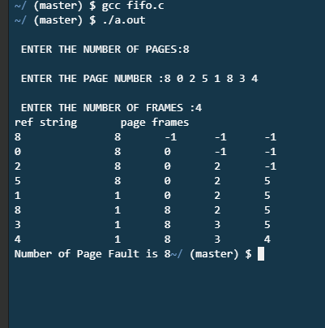

## Optimal Page Replacement:

### SOURCE CODE:

#include<stdio.h>

int main()

{

int no_of_frames, no_of_pages, frames[10], pages[30], temp[10], flag1, flag2, flag3, i, j, k, pos, max, faults = 0;

printf("Enter number of frames: ");

scanf("%d", &no_of_frames);

printf("Enter number of pages: ");

scanf("%d", &no_of_pages);

printf("Enter page reference string: ");

for(i = 0; i < no_of_pages; ++i){

scanf("%d", &pages[i]);

}

for(i = 0; i < no_of_frames; ++i){

frames[i] = -1;

}

for(i = 0; i < no_of_pages; ++i){

flag1 = flag2 = 0;

for(j = 0; j < no_of_frames; ++j){

if(frames[j] == pages[i]){

flag1 = flag2 = 1;

break;

}

}

if(flag1 == 0){

for(j = 0; j < no_of_frames; ++j){

if(frames[j] == -1){

faults++;

frames[j] = pages[i];

flag2 = 1;

break;

}

}

}

if(flag2 == 0){

flag3 =0;

for(j = 0; j < no_of_frames; ++j){

temp[j] = -1;

for(k = i + 1; k < no_of_pages; ++k){

if(frames[j] == pages[k]){

temp[j] = k;

break;

}

}

}

for(j = 0; j < no_of_frames; ++j){

if(temp[j] == -1){

pos = j;

flag3 = 1;

break;

}

}

if(flag3 ==0){

max = temp[0];

pos = 0;

for(j = 1; j < no_of_frames; ++j){

if(temp[j] > max){

max = temp[j];

pos = j;

}

}

}

frames[pos] = pages[i];

faults++;

}

printf("\n");

for(j = 0; j < no_of_frames; ++j){

printf("%d\t", frames[j]);

}

}

printf("\n\nTotal Page Faults = %d", faults);

printf("\n\n Total Page hits = %d",no_of_pages-faults);

fflush(stdin);

float a = (faults*100)/no_of_pages;

printf("\n\n Page fault percentage = %g",a);

return 0;

}

### OUTPUT:

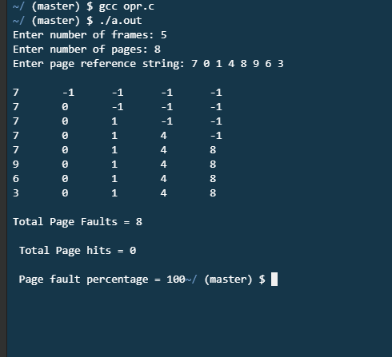

## Least Recently Used:

### SOURCE CODE:

#include<stdio.h>

int findLRU(int time[], int n){

int i, minimum = time[0], pos = 0;

for(i = 1; i < n; ++i){

if(time[i] < minimum){

minimum = time[i];

pos = i;

}

}

return pos;

}

int main()

{

int no_of_frames, no_of_pages, frames[10], pages[30], counter = 0, time[10], flag1, flag2, i, j, pos, faults = 0;

printf("Enter number of frames: ");

scanf("%d", &no_of_frames);

printf("Enter number of pages: ");

scanf("%d", &no_of_pages);

printf("Enter reference string: ");

for(i = 0; i < no_of_pages; ++i){

scanf("%d", &pages[i]);

}

for(i = 0; i < no_of_frames; ++i){

frames[i] = -1;

}

for(i = 0; i < no_of_pages; ++i){

flag1 = flag2 = 0;

for(j = 0; j < no_of_frames; ++j){

if(frames[j] == pages[i]){

counter++;

time[j] = counter;

flag1 = flag2 = 1;

break;

}

}

if(flag1 == 0){

for(j = 0; j < no_of_frames; ++j){

if(frames[j] == -1){

counter++;

faults++;

frames[j] = pages[i];

time[j] = counter;

flag2 = 1;

break;

}

}

}

if(flag2 == 0){

pos = findLRU(time, no_of_frames);

counter++;

faults++;

frames[pos] = pages[i];

time[pos] = counter;

}

printf("\n");

for(j = 0; j < no_of_frames; ++j){

printf("%d\t", frames[j]);

}

}

printf("\n\nTotal Page Faults = %d", faults);

printf("\n\n Total Page hits = %d",no_of_pages-faults);

fflush(stdin);

float a = (faults*100)/no_of_pages;

printf("\n\n Page fault percentage = %g",a);

return 0;

}

### OUTPUT:

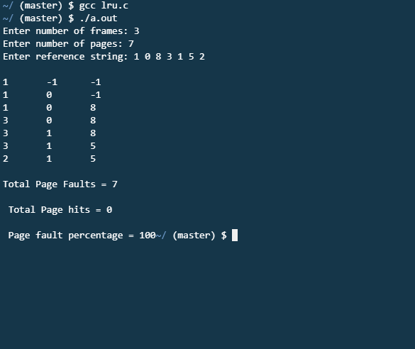

## Second Chance:

### SOURCE CODE:

#include<stdio.h>

int n,nf;

int in[100];

int p[50];

int hit=0;

int i,j,k;

int pgfaultcnt=0;

void getData()

{

printf("\nEnter length of page reference sequence:");

scanf("%d",&n);

printf("\nEnter the page reference sequence:");

for(i=0; i<n; i++)

scanf("%d",&in[i]);

printf("\nEnter no of frames:");

scanf("%d",&nf);

}

void initialize()

{

pgfaultcnt=0;

for(i=0; i<nf; i++)

p[i]=9999;

}

int isHit(int data)

{

hit=0;

for(j=0; j<nf; j++)

{

if(p[j]==data)

{

hit=1;

break;

}

}

return hit;

}

int getHitIndex(int data)

{

int hitind;

for(k=0; k<nf; k++)

{

if(p[k]==data)

{

hitind=k;

break;

}

}

return hitind;

}

void dispPages()

{

for (k=0; k<nf; k++)

{

if(p[k]!=9999)

printf(" %d",p[k]);

}

}

void dispPgFaultCnt()

{

printf("\nTotal no of page faults:%d",pgfaultcnt);

}

void secondchance()

{

int usedbit[50];

int victimptr=0;

initialize();

for(i=0; i<nf; i++)

usedbit[i]=0;

for(i=0; i<n; i++)

{

printf("\nFor %d:",in[i]);

if(isHit(in[i]))

{

printf("No page fault!");

int hitindex=getHitIndex(in[i]);

if(usedbit[hitindex]==0)

usedbit[hitindex]=1;

}

else

{

pgfaultcnt++;

if(usedbit[victimptr]==1)

{

do

{

usedbit[victimptr]=0;

victimptr++;

if(victimptr==nf)

victimptr=0;

}

while(usedbit[victimptr]!=0);

}

if(usedbit[victimptr]==0)

{

p[victimptr]=in[i];

usedbit[victimptr]=1;

victimptr++;

}

dispPages();

}

if(victimptr==nf)

victimptr=0;

}

dispPgFaultCnt();

}

int main()

{

getData();

secondchance();

}

### OUTPUT:

